# ABSTRACT

The "Online Movie Ticket Booking" project is a minor project that aims to develop a web-based platform for convenient and hassle-free booking of movie tickets. The project focuses on enhancing the traditional movie ticket booking process by providing users with an online platform where they can easily search for movies, select seats and ratings.

The project utilizes modern web technologies and follows a user-centered design approach to ensure a seamless and intuitive user experience. Users can create accounts, browse through a comprehensive list of movies, and access detailed information such as movie descriptions, ratings and crew. The application also provides a search feature that allows users to quickly find movies based on genres, languages, or release dates.

Once a movie is selected, users can view available show timings, select seats from an interactive seating layout, and proceed to the payment gateway for secure transaction processing.

Additionally, the application incorporates a user-friendly and responsive design that adapts to different devices, including desktops, tablets, and mobile phones, enabling users to access the platform from anywhere at any time.

The "Online Movie Ticket Booking" project aims to simplify the movie ticket booking process, save time, and provide users with a convenient and enjoyable movie-going experience. By leveraging the power of technology, this project strives to bridge the gap between movie enthusiasts and the cinema industry, facilitating seamless interactions and enhancing customer satisfaction.

**Table of Contents**

ABSTRACT i

LIST OF FIGURES iii

LIST OF TABLES iv

ABBREVIATIONS v

Chapter 1: INTRODUCTION 1

1.1 Background and Statement of Problem 1

1.2 Objectives and scope 2

• To make easy to book ticket at home and form anywhere without visiting cinema and waiting in a long queue. 2

Scope: 2

1.3 Applications 2

Chapter 2: LITERATURE REVIEW 3

Chapter 3: METHODOLOGY 5

3.1 System Design 5

3.2 Algorithms 7

3.4 Hardware and software required. 8

3.5 Implementation Plan 8

3.6 Expected Outputs 9

Chapter 4: FEASIBILITY ANALYSIS 10

4.1 Schedule 10

4.2 Financial Plan 11

4.3 Technical Feasibility 11

4.4 Operational Feasibility 12

Chapter 5: CONCLUSION 13

REFERENCES 14

# LIST OF FIGURES

Figure 3.1.1 Block Diagram of System ................................................................... 5

Figure 3.1.2 Use Case Diagram of System ………………………………………. 6

Figure 3.1.3 E-R Diagram of System ……………………………………………. 6

# LIST OF TABLES

Table 4.1 Gantt Chart .............................................................................................. 5

Table 4.2 Cost Estimation ........................................................................................ 5

# ABBREVIATIONS

*ER – Entity Relationship*

# Chapter 1: INTRODUCTION

## Background and Statement of Problem

Background:

The entertainment industry has witnessed a significant transformation with the advent of technology, particularly in the way people book movie tickets. Traditional methods of purchasing tickets, such as standing in long queues at cinema counters or relying on telephonic bookings, often result in inconvenience and time wastage for moviegoers. To address these challenges and enhance the overall movie ticket booking experience, the development of an online platform becomes crucial.

Online movie ticket booking systems have gained popularity due to their convenience, accessibility, and time-saving nature. These platforms allow users to browse movies, select show timings, choose seats, and make payments from the comfort of their homes or on the go. They also provide additional information about movies, empowering users to make informed choices.

Problem Statement:

Despite the availability of various online movie ticket booking platforms, there are still certain issues and challenges that need to be addressed. These include:

**1.Lack of a Comprehensive Platform**: Many existing online movies ticket booking systems fail to offer a comprehensive platform that combines features like movie selection, show timings, seat selection, and secure payment processing in a user-friendly manner.

**2.Limited Availability Information**: Users often face difficulties in accessing information on seat availability for specific shows. This can result in frustration and inconvenience when seats are not available after going through the booking process.

**3.Inconsistent User Experience**: Some online platforms suffer from usability issues, confusing interfaces, and inconsistent user experiences across different devices, such as desktops, tablets, and mobile phones.

## Objectives and scope

Objective:

## To make easy to book ticket at home and form anywhere without visiting cinema and waiting in a long queue.

## Scope:

* This project we have carried out was a learning curve for us in development of such systems.
* In future we can scale this project by adding different dynamic interfaces for different mobile.
* Allow users to add comments and subsequent.
* Allow users to rate movies after watching them in the theatre.

## 1.3 Applications

The "Online Movie Ticket Booking" system has wide-ranging applications in the entertainment industry. It can be utilized by movie theaters, multiplexes, and cinema chains to streamline the ticket booking process, increase operational efficiency, and enhance customer satisfaction. By implementing this system, cinema operators can provide a convenient and user-friendly platform for moviegoers to book tickets, resulting in a seamless movie experience.

The application can also benefit movie enthusiasts who can easily browse through a wide selection of movies, view show timings, and select seats based on their preferences. They can conveniently make secure online payments and reducing the risk of counterfeit tickets. The system can also provide users with additional information about movies, such as trailers, ratings, reviews, and recommendations, allowing them to make informed decisions before booking.

Overall, the "Online Movie Ticket Booking" system has practical applications for both cinema operators and movie enthusiasts, providing a convenient, efficient, and enjoyable movie ticket booking experience. It revolutionizes the traditional ticketing process, leveraging technology to bridge the gap between moviegoers and the cinema industry.

# Chapter 2: LITERATURE REVIEW

Online movie ticket booking system is a convenient way of booking movie tickets online. The project “Online Movie Ticket Booking System” is dedicated to the general requirements of multiple theaters The main objective of the project is to create an Online Movie Ticket Booking processing that allows customers to know about new movies & their schedules& cinema locations& class and ticket price etc.

From the past 18 years in South Africa [5] a seed of an idea of book my show was planted. The site was started in 1999, and since then it is one of the most famous online movie booking system. The web site mostly gained popularity between the years 2006-2010. Book My Show [6] was awarded 'The Hottest Company of the Year-2011-12 and “'The Company to watch out for' at the prestigious CNBC Young Turks Award. In May 2016 BookMyShow awarded ‘Best Omni-channel Customer Experience Brand’ at the One Direct Quest Customer Experience (Quest CX) Awards. It uses a PHP based web site. The web site provides detailed information regarding movies. There are columns in which reviews can be added and published on the web page. These sorts of features are almost common in all the web sites available.[7]

Golden Village Pictures (GVP) [8] was established in 1993. It is Singapore's leading independent film distributor. It has been seen for long that entertainment is very much popular in some of the smaller countries like Singapore and Dubai. GV is considered as the backbone of movie system in Singapore. It holds 11 multiplexes housing 92 screens with locations at different locations. Golden Village was established to develop and operate modern, luxurious multiplex cinemas and is the first local cinema to personalize the movie-going experience through its Movie Club program. In the year 2016, GVP [8] brought SULLY and PASSENGERS, both produced by Village Roadshow Pictures, and Jackie Chan’s RAILROAD TIGERS. When we look at the software part it uses responsive web designing with Bootstrap. Back end is supported by PHP and SQL database connectivity. Quick Buy Check Booking and Check buy are other options for ticket booking. Shop merchandise, movie voucher code & cards, corporate are the other modules and functionalities of the web site. Posters and the trailer of the upcoming movies have also been shown on the web site.

On further research on these systems there are some problems in the online movie system. Due to the increasing traffic and demand , the system may not be able to handle the load. In the context of Nepal, most of the multiplex cinemas such as QFX, big movies, fcube etc., provides ticket reserving/booking and buying . users can login to app or website . seat confirmation and payment can easily be done using online payment portal which is further connected to khalti, ime pay, esewa.

# Chapter 3: METHODOLOGY

## The methodology employed for our project follows an iterative and incremental approach, specifically the Agile methodology. This methodology allows for flexibility, collaboration, and continuous improvement throughout the development process.

## 3.1 System Design

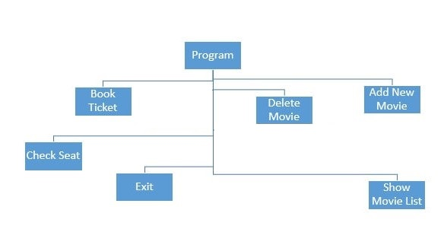

*Fig 3.1.1: Block diagram*

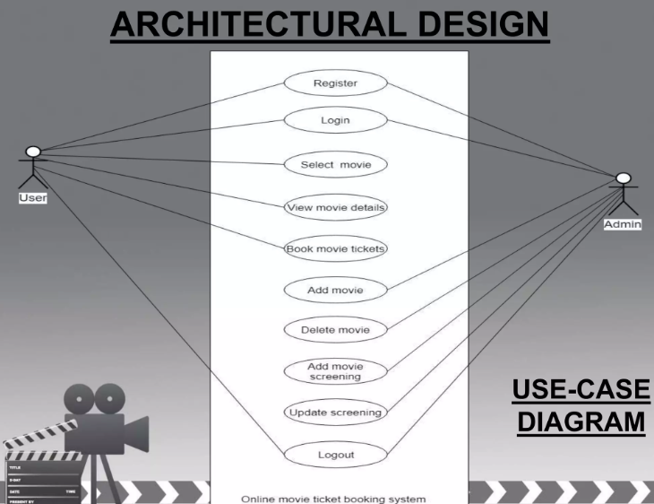

*Fig 3.1.2: Use Case diagram*

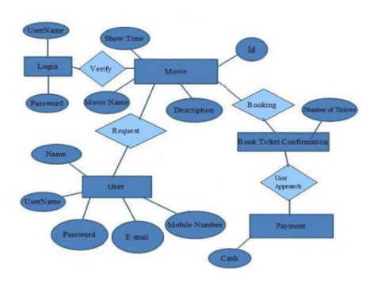

*Fig 3.1.3: ER-diagram*

## 3.2 Algorithms

Steps :

1. User Registration and Authentication:

* Users create an account or log in using their credentials.
* Validate user input and authenticate user credentials.

1. Movie and Theater Listing:

* Retrieve a list of available movies and associated theaters from the database.
* Display movie and theater information to the user.

1. Seat Selection:

* Display an interactive seating layout to the user.
* Allow users to select their preferred seats.

1. Booking and Payment:

* Calculate the total cost of the selected seats.
* Collect user payment details and process the payment securely.

1. Booking Confirmation:

* Generate a booking confirmation with details such as movie, seats, and payment information.
* Display the booking confirmation to the user.

**3.3 Assumptions**

Availability of Movie and Theater Data: It is assumed that the system has access to a reliable and up-to-date database or API that provides accurate information about movies, theaters, showtimes, seating layouts, and other relevant details.

Seat Availability: The system assumes that seat availability information is accurate and updated in real-time. It is assumed that proper synchronization between user interactions and seat status is maintained to prevent double bookings.

User Authentication and Security: It is assumed that the system implements robust user authentication mechanisms, such as secure password hashing and session management, to ensure the privacy and security of user accounts.

Responsive User Interface: The system assumes a user-friendly and responsive interface that can adapt to different devices and screen sizes, providing an optimal user experience on desktop and mobile platforms.

Network Connectivity: It is assumed that users have a stable internet connection to access and interact with the online movie ticket booking system.

## 3.4 Hardware and software required.

3.4.1 Hardware Requirements:

1. Intel core i3 2nd generation is used as a processor because it is faster & provide reliable and stable working environment.

2. A RAM size of 4 gb is used as it will provide fast reading & writing capabilities.

3.4.2 Software Requirements:

1.Operating System: The server should run a reliable and secure operating system, such as Linux, Windows Server, or Unix, to ensure stable and efficient system performance.

2.Programming Languages: The system can be developed using programming languages like HTML, CSS, JavaScript for the front-end, and back-end languages like Python for server-side processing and database connectivity.

3.Database Management System: A robust and scalable database management system (DBMS) is needed to store and manage data. Popular choices include MySQL.

## 3.5 Implementation Plan

There are different systems tools that have been used in developing both the front-end, back-end.

3.5.1 FRONT END:

JSP, HTML, CSS, JS, BOOT STRAP are used to implement the frontend.

HTML (Hyper Text Markup Language)

CSS (Cascading Style Sheets)

JS (Java Script)

3.5.2 BACK END

For the back-end implementation MySQL is used and that is used to design the

Databases

Python – wide range of frameworks and libraries

## 3.6 Expected Outputs

* Movie Listing:

Display a list of available movies with details such as title, genre, and poster.

Present showtime options along with details like date, time, and available seats.

* Seat Selection:

Show an interactive seating layout for the chosen showtime and theater.

Highlight available seats and provide options for users to select their preferred seats.

* Booking and Payment:

Generate a booking confirmation page with details such as movie title, showtime, and selected seats.

Present a payment interface for users to enter payment details and complete the transaction.

# Chapter 4: FEASIBILITY ANALYSIS

## 4.1 Schedule

Our project completion is structured into three phases. The initial phase consists of 10 days dedicated to in-depth research and meticulous planning to ensure a comprehensive understanding of the project requirements. Subsequently, we allocate 15 days for the development of the front-end, focusing on creating a user-friendly and visually appealing interface. Simultaneously, we allot 15 days for back-end development, ensuring robust functionality and seamless integration with databases and APIs.

According to our schedule, the project is estimated to be completed within a total duration of 40 days. Following the development phase, we will conduct parallel activities for documentation and rigorous testing to ensure high quality and compliance with project specifications. This professional approach ensures a systematic and well-structured project execution. Table

**4.1 Gantt Chart**

|  |  |  |  |  |
| --- | --- | --- | --- | --- |
| S.N. | Tasks | Month | | |
|  | Research | 6/11 | 6/20 |  |
|  | Front-end | 6/21 | 7/5 |  |
|  | Back-end | 7/6 | 8/20 |  |
|  | Implementation and documentation | 8/21 | So on |  |

## 

## 4.2 Financial Plan

In line with our project evaluation, we have determined the cost estimation for this project to be Rs. 400 per hour. Our plan is to allocate 2 hours per day for a duration of 40 days, with a dedicated team of 4 members working on the project. Based on these parameters, the daily cost will amount to Rs. 3200. Multiplying this daily cost by the total duration of 40 days and considering the 4 team members, the projected budget for this project is calculated to be Rs. 128,000. We present this formal cost estimation as a guideline for the financial aspects of the project, ensuring transparency and clarity in terms of budget allocation.

### Table 4.2 Cost Estimation

|  |  |  |  |
| --- | --- | --- | --- |
| S.N. | Item | Cost per unit | Total Cost |
| 1 | Research | Rs. 1600 per hour | Rs. 32000 |
| 2 | Implementation | Rs. 1600 per hour | Rs. 48000 |
| 3 | Coding | Rs. 1600 per hour | Rs. 48000 |
| 4 | documentation | Rs. 400 per hour for single member | According to needs |

## 4.3 Technical Feasibility

The technical feasibility of our project relies on having skilled development resources, robust infrastructure for hosting and scalability, seamless integration with third-party services, implementation of strong security measures, user-friendly interface, thorough testing and quality assurance, and a plan for ongoing maintenance and support.

## 4.4 Operational Feasibility

Based on our thorough assessment of the project criteria, we are confident in our ability to successfully execute this project within the defined parameters. The allocated schedule allows for completion within the designated timeframe.

Regarding maintenance, ongoing costs for hosting and domain services will be incurred on a monthly basis. These expenses are essential for the continued operation of the system.

One of the strengths of our system is its user-friendly interface, which ensures ease of use for all users. Additionally, the administrative aspect of the system requires some technical knowledge to manage movie additions, removals, and scheduling. This may entail the involvement of technical resources to handle these operations effectively.

Considering these factors, we acknowledge that there may be costs associated with technical resources for system operation and administration. However, these costs are necessary to maintain the functionality and usability of the system.

# Chapter 5: CONCLUSION

In conclusion, the development of an online movie ticket booking system addresses the limitations and challenges faced by traditional ticket booking methods. By leveraging modern web technologies, the system offers a comprehensive and user-friendly platform for movie enthusiasts to conveniently view show timings, select seats, and make secure online payments.

Through the implementation of this system, cinema operators can enhance operational efficiency, streamline the ticket booking process, and provide a seamless movie experience for their customers.

Overall, the online movie ticket booking system revolutionizes the movie ticketing process, bridging the gap between moviegoers and the cinema industry. It offers convenience, accessibility, and enhanced user experiences, contributing to customer satisfaction and business growth. By embracing this technology-driven approach, the system empowers cinema operators and movie enthusiasts to navigate the entertainment industry efficiently and enjoy a seamless movie-going experience.

# REFERENCES

[1] Balan, Mihai. "GPRS-Based Cinema Ticket Reservation System." (2007).

[2] PV, SREEJESH, et al. MULTIPLEX THEATER ONLINE BOOKING SYSTEM. 2014. APA

[3] www.postgresql.org. Postgresql relational database system.

[4] Thomas M. Connolly, Carolyn E. Begg, “Database Systems & Practical Approach to Design Implementation and Management”

[5] [1] D. K. Gangeshwer, “[PDF] e-commerce or internet marketing: A business review from Indian context: Semantic scholar,” International Journal of u- and e- Service, Science and Technology, https://www.semanticscholar.org/paper/E-Commerce-or-Internet-Marketing:-A-Business-Review-Gangeshwer/b3e35017f85675356ffe262233a8a0c568df6913 (accessed Jun. 8, 2023).

[6] [1] Synchronized, “GV (Google Ventures),” GV, https://www.gv.com/ (accessed Jun. 8, 2023).